**ICT10013 Distinction Task 1 Submission**

**Student Name: Mario Stavreski Student ID: 103055993**

=====================================================================

Copy and paste the HTML here between the dotted lines

This must be editable code (not a screen shot)

<html lang="en">

<head>

    <meta charset="UTF-8">

    <meta name="viewport" content="width=device-width, initial-scale=1.0">

    <link rel="stylesheet" href="TBS.css">

    <script src="TBS.js"></script>

    <title>CSBS</title>

</head>

<body>

    <header>

        <div class="welcome_div sansserif">

            <h1 style="text-align: center">Welcome to the Tour Booking System</h1>

            <p></p>

        </div>

    </header>

    <main>

        <div class="container">

            <form action="#" onsubmit="return false">

             <div class="row">

                 <div class="col-25">

                     <label for="name">Name</label>

                 </div>

                 <div class="col-75">

                    <input type="text" name="name" id="name" placeholder="Enter Name">

                 </div>

             </div>

             <div class="row">

                <div class="col-25">

                    <label for="tourCode">Tour Code</label>

                </div>

                <div class="col-75">

                   <input type="text" name="tourCode" id="tourCode" placeholder="Tour Code">

                </div>

            </div>

            <div class="row">

                <div class="col-25">

                    <label for="lunchCode">Lunch Code</label>

                </div>

                <div class="col-75">

                   <input type="text" name="lunchCode" id="lunchCode" placeholder="Lunch Code">

                </div>

            </div>

            <div class="row">

                <div class="col-25">

                    <label for="noOfGuest">Number of Guests</label>

                </div>

                <div class="col-75">

                   <input type="text" name="noOfGuest" id="noOfGuest" min=0 placeholder="Number of Guests">

                </div>

            </div>

            <div class="row">

                <div class="col-25">

                    <label for="agentId">Agent ID</label>

                </div>

                <div class="col-75">

                   <input type="text" name="agentId" id="agentId" placeholder="Agent ID">

                </div>

            </div>

            <br>

           <hr>

            <div class="row">

                <div class="col-25">

                </div>

                <div class="col-75  buttons">

                   <input type="submit" onclick=" displayTourOptions()" value="Tour-Option">

                   <input type="submit" onclick="displayLunchOptions()" value="Lunch-Option">

                   <input type="submit" onclick="validateAndCal()" value="Submit">

                </div>

            </div>

            <div class="row">

                <div class="col-25">

                  <label for="price">Price</label>

                </div>

                <div class="col-75">

                    <p id="price" name="price"></p>

                </div>

              </div>

              <div class="row">

                <div class="col-25">

                  <label for="data">Show Data</label>

                </div>

                <div class="col-75">

                    <p id="data" name="data"></p>

                </div>

              </div>

            </form>

        </div>

    </main>

    <footer>

        <div class="footer_div sansserif">

            <p >Copyright &copy; 2020 All Rights Reserved by Mario Stavreski.

           </p>

        </div>

    </footer>

</body>

</html>

=====================================================================

Copy and paste the CSS code here between the dotted lines

This must be editable code (not a screen shot)

.sansserif {

    font-family: Arial, Helvetica, sans-serif;

}

body{

}

.welcome_div{

   background-color: rgba(0,26,73,0.8);

   color: #fff;

   margin: 0;

   padding: 1rem 2rem;

   text-align: center;

}

.footer_div{

   background-color: rgba(0, 0, 0, 0.8);

   color: #fff;

   margin: 0;

   padding: 1rem 2rem;

   text-align: center;

}

.footer_div a{

    text-decoration: none;

    color: antiquewhite;

}

* {

   box-sizing: border-box;

}

   input[type=text],input[type=number], select, textarea {

   width: 100%;

   padding: 12px;

   border: 1px solid #ccc;

   border-radius: 4px;

   resize: vertical;

   }

label {

padding: 12px 12px 12px 0;

display: inline-block;

color: darkblue;

}

input[type=submit]{

background-color: #4CAF50;

color: white;

padding: 12px 20px;

border: none;

border-radius: 4px;

cursor: pointer;

float: inherit;

}

input[type=submit]:hover {

background-color: #45a049;

}

.container {

border-radius: 5px;

background-color: #f2f2f2;

padding: 20px;

}

.col-25 {

font-family: Arial, Helvetica, sans-serif;

float: left;

width: 25%;

margin-top: 6px;

}

.col-75 {

float: left;

width: 75%;

margin-top: 6px;

}

/* Clear floats after the columns */

.row:after {

content: "";

display: table;

clear: both;

}

/* Responsive layout - when the screen is less than 600px wide, make the two columns stack on top of each other instead of next to each other */

@media screen and (max-width: 600px) {

.col-25, .col-75, input[type=submit] {

   width: 100%;

   margin-top: 0;

   margin-top: 2px;

}

.buttons{

   text-align: center !important;

   display: inline-block !important;

   justify-content: center !important;

}

}

.buttons{

text-align: center;

display: flex;

justify-content: space-around;

}

=====================================================================

Copy and paste the JavaScript code here between the dotted lines

This must be editable code (not a screen shot)

var tourCodes=["H","F","A"];

var tourNames=["Half-day City Sightseeing","Full-day City Sightseeing","City Sightseeing  + Art museum"];

var tourPrices=[80,130,170];

var lunchTypes=["OG","2C","3C","GL"];

var lunchNames=["On-the-Go","2-Course","3-Course","Gourmet"];

var lunchPrices=[10,17,27,32];

function addToOutput(str,num){

    if(num==0){

        document.getElementById("price").innerHTML="The total price of the tour is: $" + str;

    }

    else if(num==1){

        document.getElementById("data").innerHTML+=str;

    }

    else if(num==2){

        document.getElementById("data").innerHTML+=str;

    }

};

function displayTourOptions(){

    document.getElementById("data").innerHTML="";

    var str="\t----Tour Prices and Options----<br> ";

    for(var i=0;i<tourCodes.length;i++){

        str=str+"\t"+tourCodes[i]+"-"+tourNames[i]+" "+tourPrices[i]+"$<br>";

    }

    addToOutput(str,2);

}

function displayLunchOptions(){

    document.getElementById("data").innerHTML="";

    var str="\t-------Lunch Options-------<br> ";

    for(var i=0;i<lunchTypes.length;i++){

        str=str+"\t"+lunchTypes[i]+"-"+lunchNames[i]+" "+lunchPrices[i]+"$<br>";

    }

    addToOutput(str,2);

}

function validateNoOfPeople(str){

    if(isNaN(str)){

        addToOutput("Number of People must be in numeric<br>",1);

        return false;

    }

    else if(str < 1 || str > 11)

    {

        addToOutput("Number of People must be between 1 and 11<br>",1);

        return false;

    }

    return true;

}

function validateName(str){

    if(str.length>25){

        document.getElementById("data").value="";

        addToOutput("Name must be between 1 and 25 characters in length<br>",1);

        return false;

    }

    return true;

}

function validateId(id){

    if(isNaN(id)){

        addToOutput("Id must be numeric<br> ",1);

    }

    if(id.length===5){

        return true;

    }

    else{

        addToOutput("Id must be 5 in length<br>",1)

    }

    return false;

}

function validateType(arr,str){

    for (var i=0;i<arr.length;i++){

        if(arr[i]==str)

        {

            return i;

        }

    }

    return -1;

}

function validateCheck(str){

    var resultA=parseInt(str[0])*parseInt(str[2]);

    var resultB=resultA+ parseInt(str[1])+parseInt(str[3]);

    var check=String(resultB);

    if(parseInt(check[0])+parseInt(check[1])===parseInt(str[4]))

    {

        return true;

    }

    addToOutput("Id has invalid check<br>",1);

    return false;

}

function calculateTourCost(index,not){

    return tourPrices[index]*not;

}

function calculateLunchCost(index,not){

    return lunchPrices[index]*not;

}

function calculateTotalPayment(ctc,clc){

    return ctc+clc;

}

function validateAndCal(){

    document.getElementById("data").innerHTML="";

    document.getElementById("price").innerHTML="";

    var name=document.getElementById("name").value;

    var tourCode=document.getElementById("tourCode").value;

    var lunchCode=document.getElementById("lunchCode").value;

    var noOfPeople=document.getElementById("noOfGuest").value;

    var id=document.getElementById("agentId").value;

    var str="";

    validateName(name);

    var tourIndex=validateType(tourCodes,tourCode.toUpperCase());

    var lunchIndex=validateType(lunchTypes,lunchCode.toUpperCase());

    if(tourIndex==-1){

        addToOutput("Invalid tour code<br>",1);

    }

    if(lunchIndex==-1){

        addToOutput("Invalid Lunch Code<br>",1);

    }

    validateCheck(id);

    if(validateId(id)===true){

        if(validateNoOfPeople(noOfPeople)==false){

        }

        else{

            var ctc;

            var clc;

            if(tourIndex==-1){

            }

            else{

                ctc= calculateTourCost(tourIndex,noOfPeople);

            }

            if(lunchIndex==-1){

            }else{

                clc= calculateLunchCost(lunchIndex,noOfPeople);

            }

            if(lunchIndex==-1 || tourIndex==-1){

            }else{

                var tc=calculateTotalPayment(parseInt(ctc),parseInt(clc));

            addToOutput(tc,0);

            }

        }

    }

}

window.onload=function(e){

   // addToOutput("as");

   console.log(this.calculateTourCost(0,2));

}

=====================================================================

Copy and paste all screen captures of testing your program here between the dotted lines

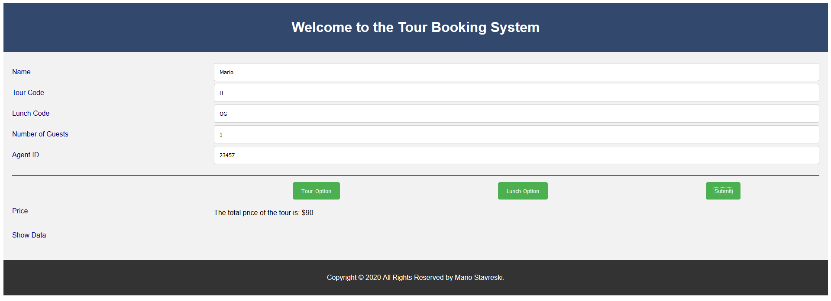

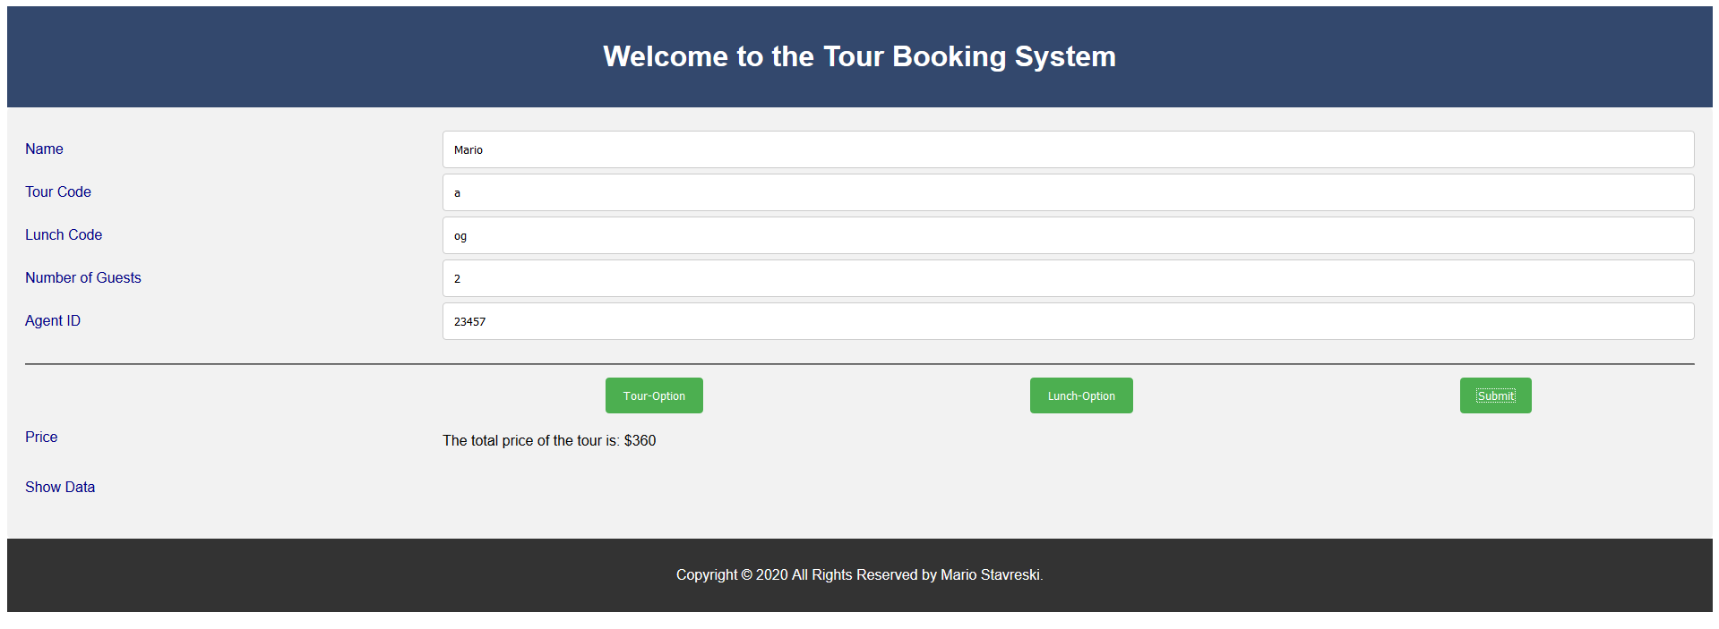

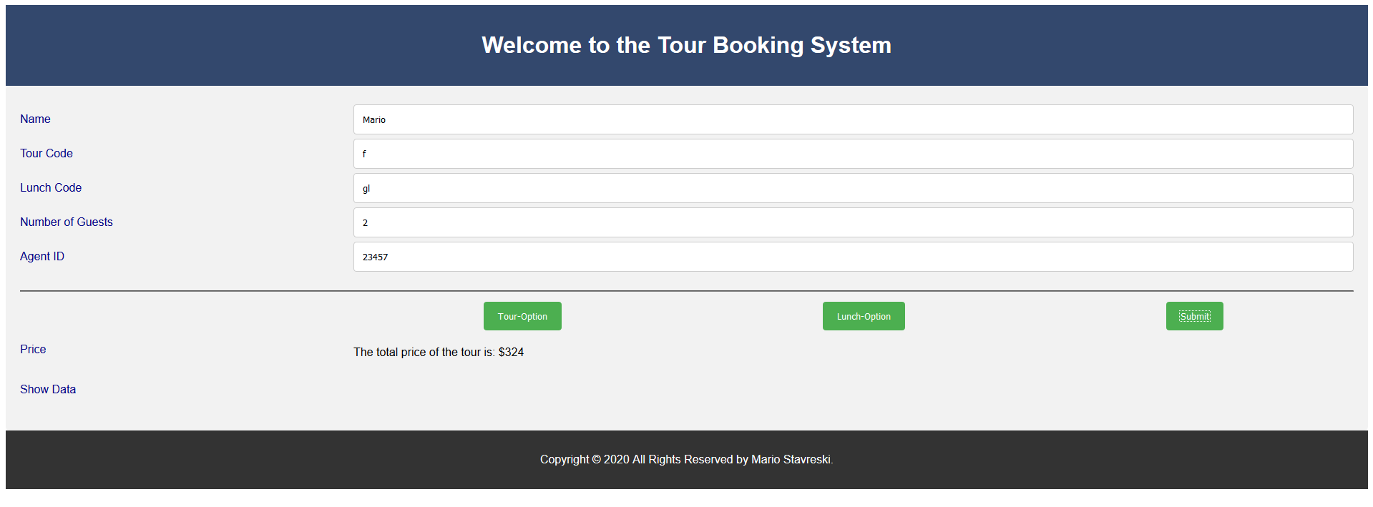

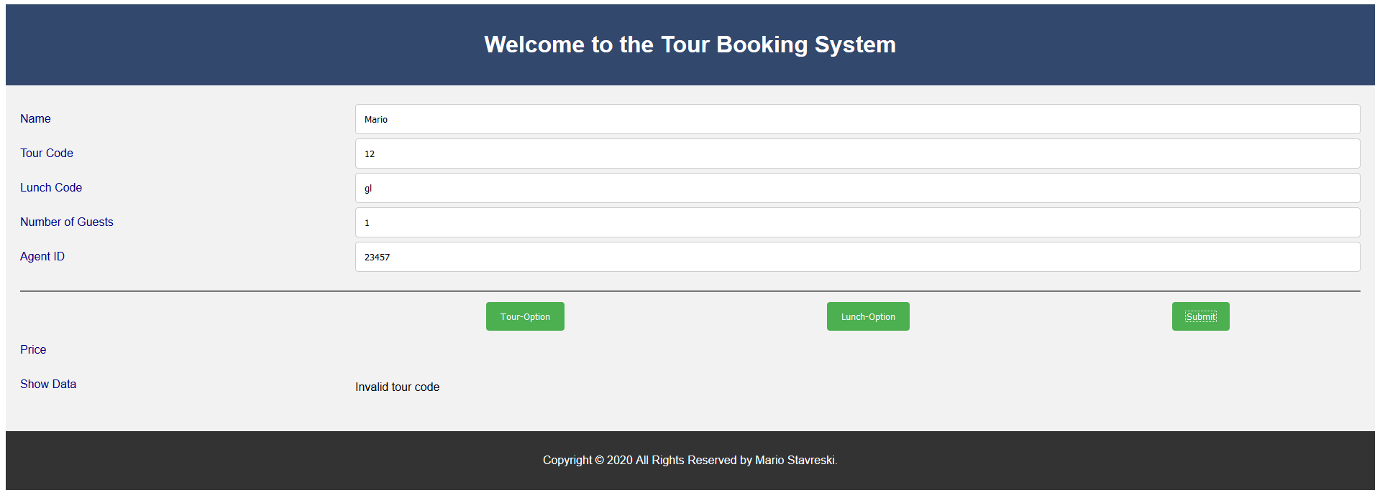

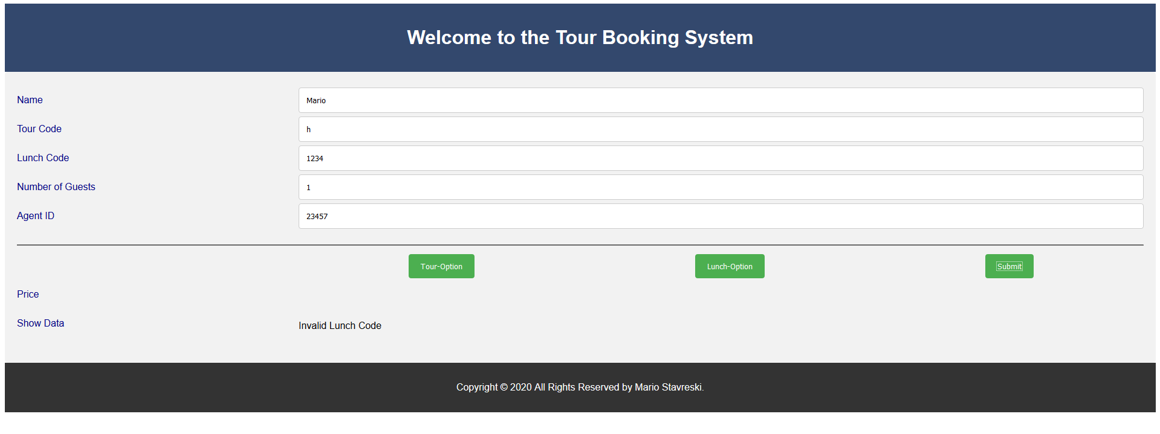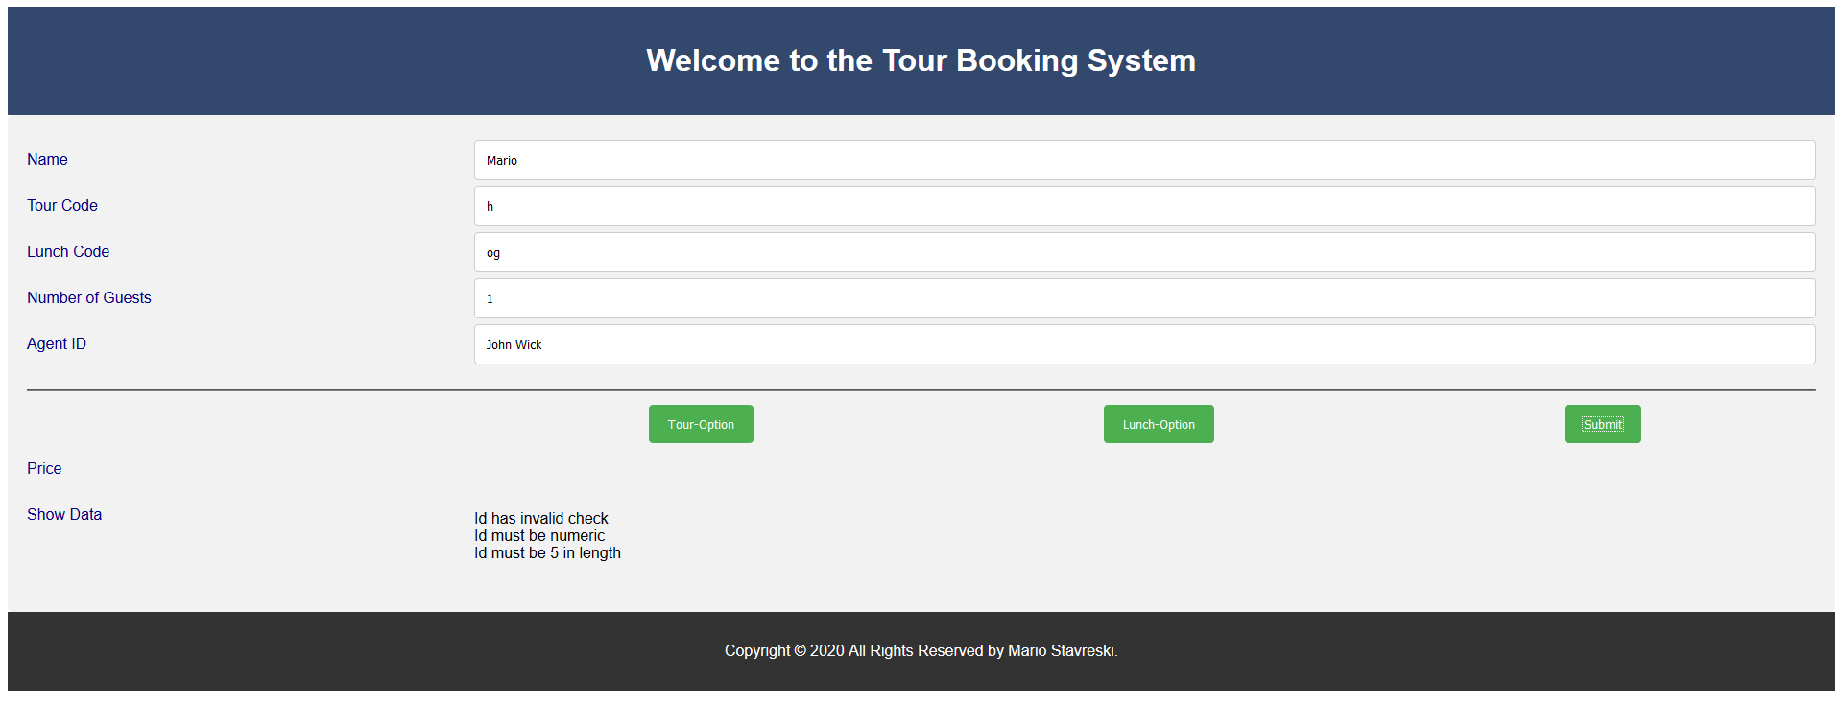

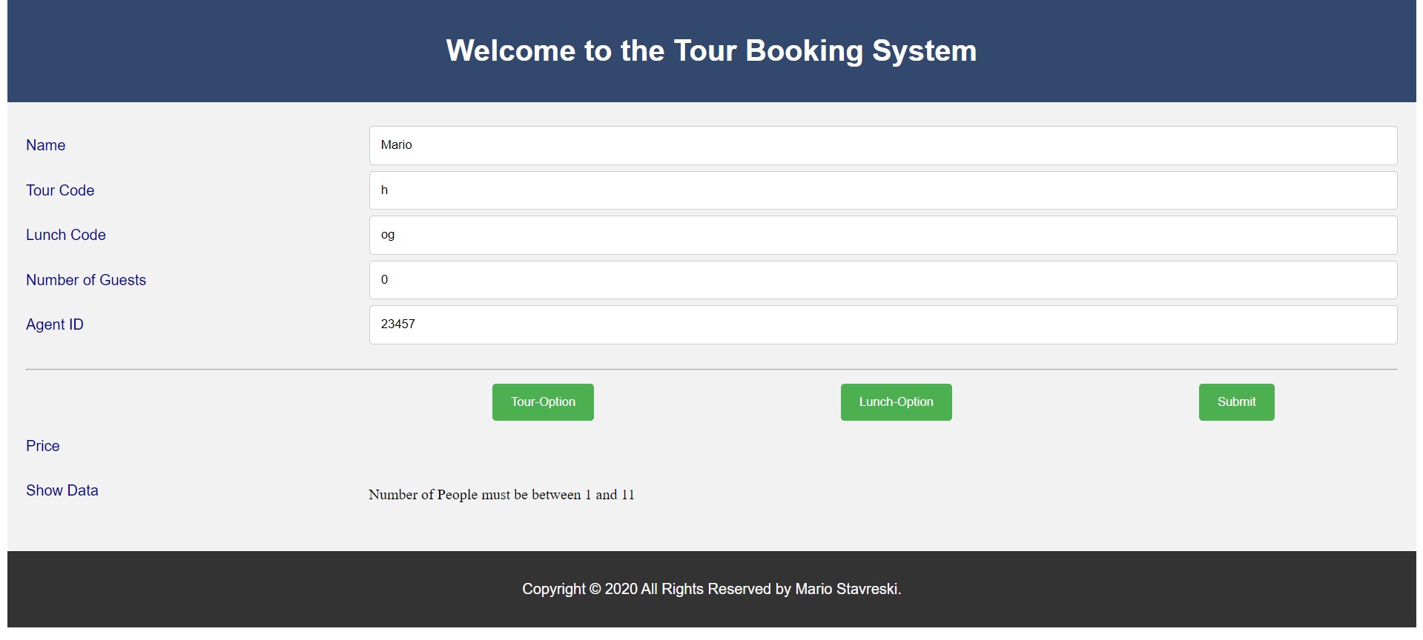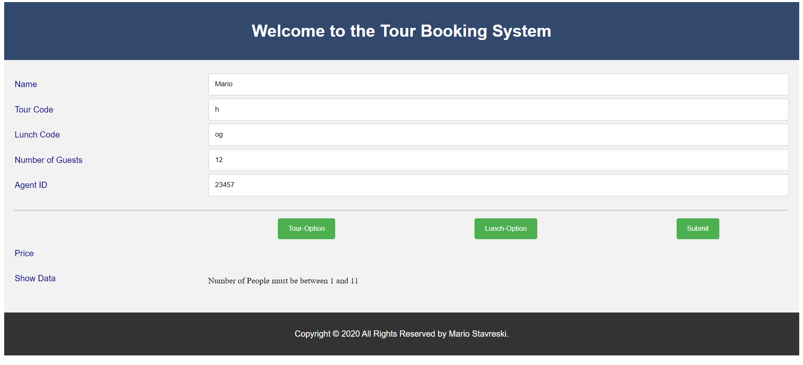

=====================================================================

Once this document is complete:

* Convert this file into a .PDF named **DTASK1.pdf**
* This file must then be uploaded via Doubtfire as task **7.3D submission**.

7. Marking Guide

Start with 20 marks then:

Apply penalties if necessary based on:

|  |  |  |  |
| --- | --- | --- | --- |
| Correctness Requirement | Perfect | Minor Problem | Major  Problems |
| HTML & meta tags | No Penalty | -1 | -2 |
| CSS code and appearance | No Penalty | -1 | -2 |
| Coding and use of addToOutput() | No Penalty | -1 | -2 |
| Coding and use of displayTourOptions () | No Penalty | -1 | -2 |
| Coding and use of displayLunchOptions () | No Penalty | -1 | -2 |
| Coding and use of validateAndCalc() | No Penalty | -1 | -2 |
| Coding and use of validateName() | No Penalty | -1 | -2 |
| Coding and use of validateId() | No Penalty | -1 | -2 |
| Coding and use of validateCheckDigit() | No Penalty | -1 | -2 |
| Coding and use of validateType () | No Penalty | -1 | -2 |
| Coding and use of validateNumberOfPeople() | No Penalty | -1 | -2 |
| Coding and use of calculateTourCost() | No Penalty | -1 | -2 |
| Coding and use of calculateLunchCost() | No Penalty | -1 | -2 |
| Coding and use of calculateTotalPayment () | No Penalty | -1 | -2 |
| Use of test data | No Penalty | -1 | -2 |
| Other penalty for unforeseen problems |  | -1 | -2 |

Any score below 14 is considered a fail.

A Satisfactory score is 14-18.

An Excellent score is 19-20 with no Major problems.

**Only ONE resubmission is allowed.**